
Company
Logotype

Cone Beam Computed Tomography- Report



Porur Dental X-rays & CBCT

Patient Name : Mrs. Saranya | Date of Report : 07.03.2024
Age/ Gender : 35 years/ Female | Region of Interest : CBCT Full Skull
Referring doctor: Dr. S. M. M. Moulvi | Indication : Temporomandibular joint pain- right side
Clinical Notes: Nil
PATIENT INFORMATION

CBCT- Full skull provided
CBCT – IMAGE DETAILS

RADIOGRAPHIC INTERPRETATION

- Missing teeth : 28, 38, 48
- Root canal treated tooth with crown: 16.
- Restored teeth: 36, 46.
During rest position – Right Temporomandibular joint:
- In relation to the right temporomandibular joint, presence of mild degenerative changes in the superior surface of the head of the condyle causing mild flattening is evident.
- Minimal flattening of the articular eminence is also evident.
- Altered superior- discal space in relation to right TMJ is evident.
During rest position – Left Temporomandibular joint:
- Altered superior- discal space in relation to left TMJ is evident.

- Length of the right styloid process: 28.9 mm.
- Length of the left styloid process: 28 mm.

RADIOGRAPHIC IMPRESSION

- Mild Internal derangement of Temporomandibular joint – Right and left side.

Kindly correlate with clinical findings


IMAGES FOR REFERENCE

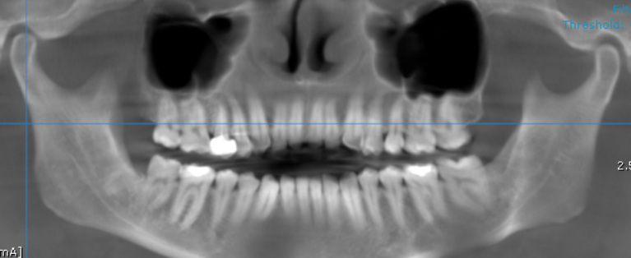

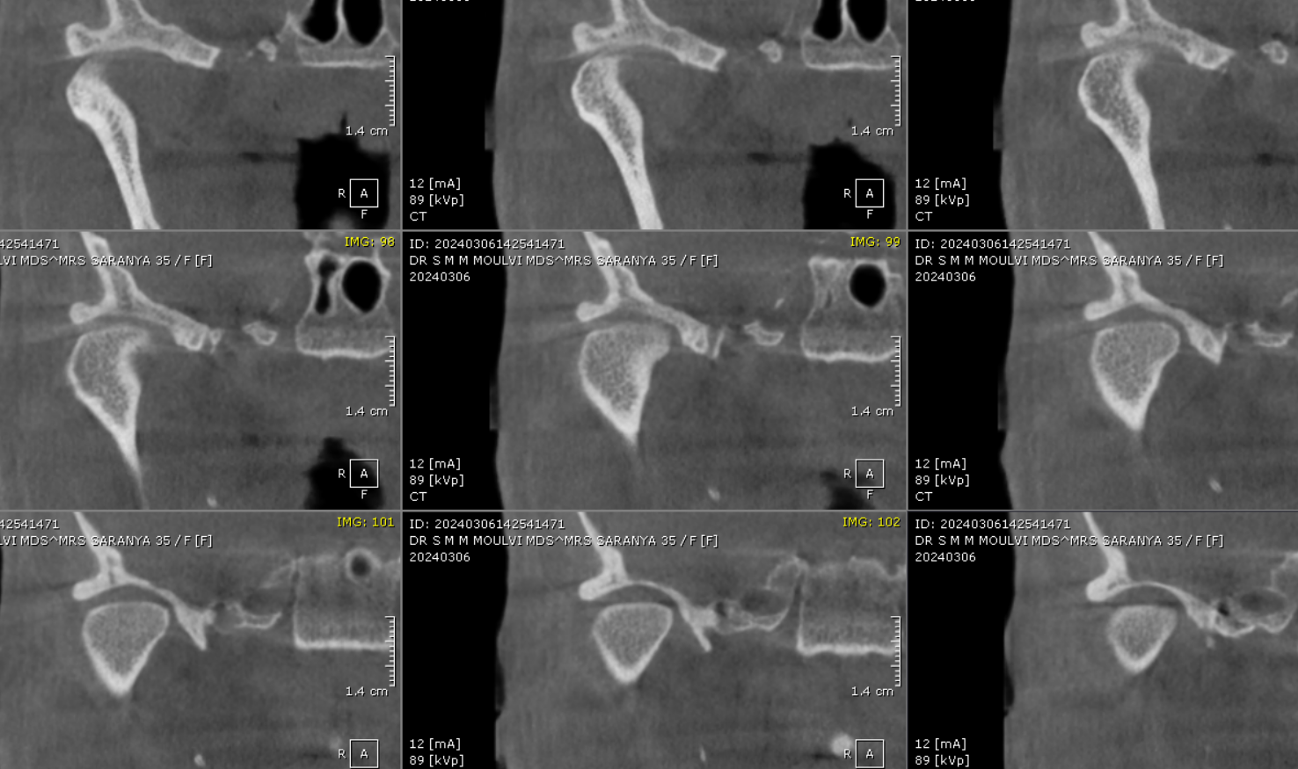

CORONAL VIEW

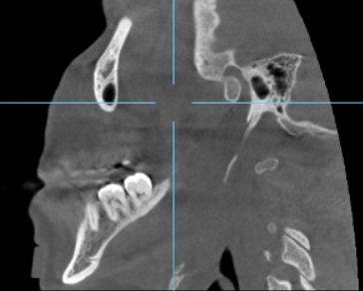
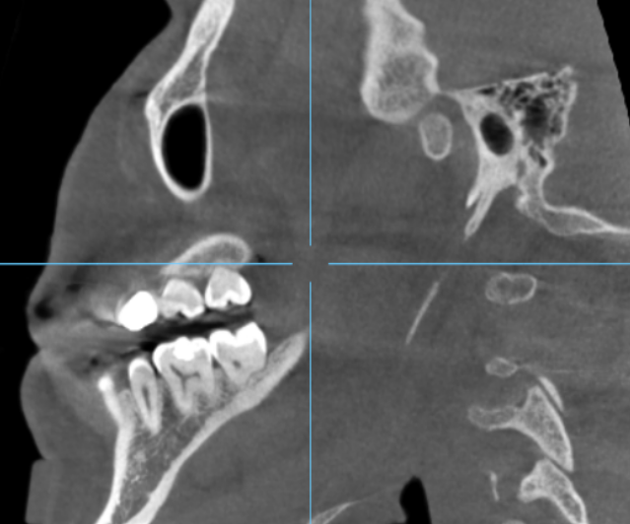
Right styloid process
Left styloid process
SAGITTAL VIEW

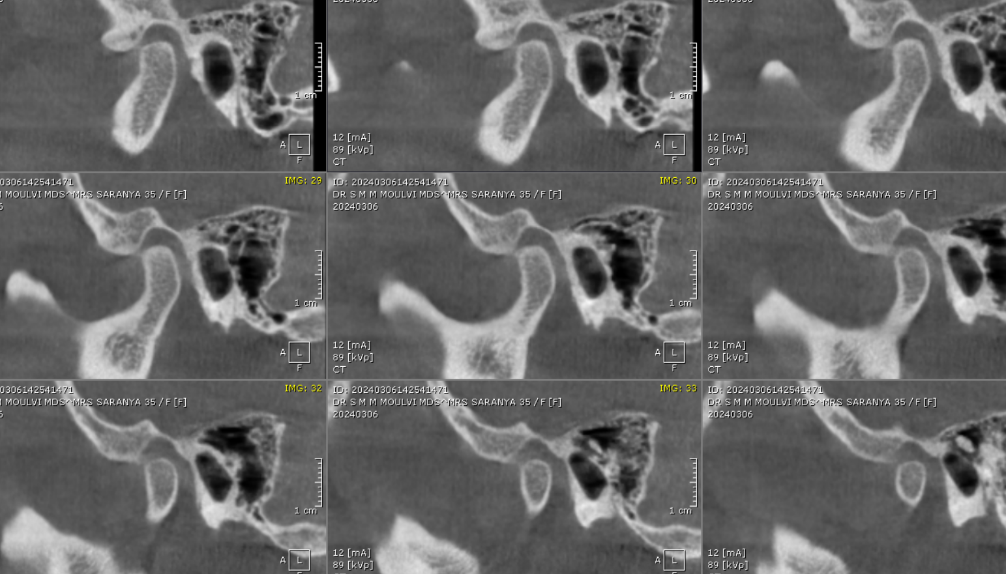

3 DIMENSIONAL VIEW

Right Side
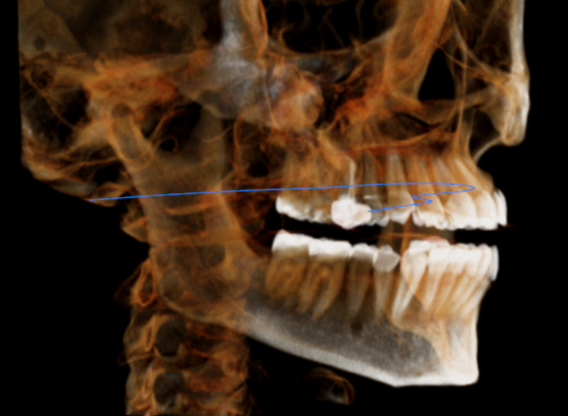

**** End of report ****

